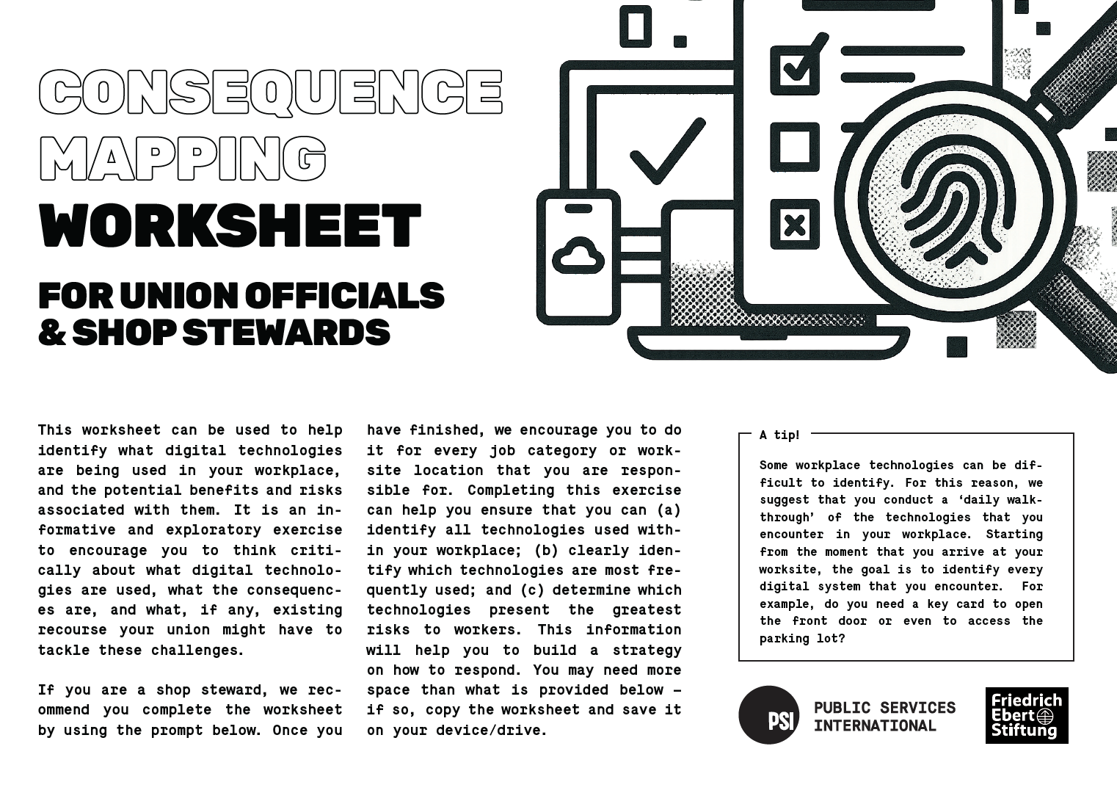

TECHNOLOGY TYPE
WHEN AND WHERE IS IT USED?
WHAT DATA IS BEING COLLECTED?
FROM YOUR EMPLOYER’S PERSPECTIVE, WHY IS THIS TECHNOLOGY BEING USED?
WHAT BENEFITS DOES OR COULD THE USE OF THIS TECHNOLOGY
PRESENT TO WORKERS?
WHAT RISKS DOES OR COULD THE USE OF THIS TECHNOLOGY PRESENT TO WORKERS? IT USED?
DO SECTIONS OF YOUR COLLECTIVE AGREEMENT OR REL- EVANT LAWS ADDRESS THESE RISKS?

IF YOU NEED MORE SPACE, DUPLICATE THE TABLE/PRINT PAGE MULTIPLE TIMES
Once you have completed this for your typical day, consider: have you ever had to work from home or a different location? Have you ever had to contact your workplace from home because, for example, you were sick? Do you have to complete any infrequent or annual reports? Did you encounter any additional technical or automated systems? If so, add those to the list!
To find out more about our Digitalisation work and access more useful resources, check out our website: publicservices.international

