AI IN HUMAN RESOURCES: An overview
The context
The field of Human Resources (HR) manages the relationship between organizations and their employees. Contemporary HR practitioners often emphasize a more individualized approach to the fulfillment of personnel functions including recruitment and selection, scheduling, the determination and delivery of compensation and benefits, performance management, and offboarding – though this approach has become increasingly common in both union and non-union contexts.
Core HR functions have become a key site for the introduction of AI related technologies within the world of work. While some AI applications in fields like performance management and scheduling systems may be evident to workers, HR systems can deploy AI systems in less-overt ways. These can include the distribution and display of job advertisements and the screening of applicants; creating individual or workforce profiles to determine compensation levels and benefits packages; or in the administration of benefits and retirement planning.
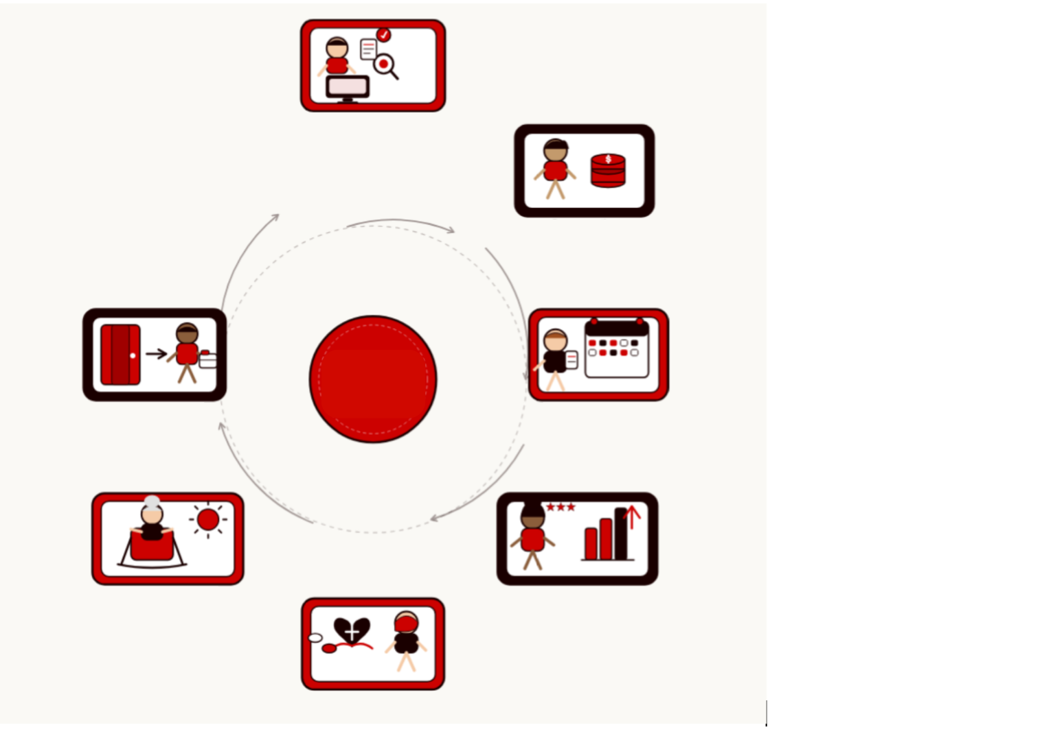
Dismissal
Termination, offboarding
Retirement
Pension, 401k, exit
Benefits admin & care
Health, dental and wellness
Performance Management
Reviews, goals, coaching
Scheduling
Shift hours, time off
Compensation
Pay and Bonuses
Recruitment & Selection
Attract, Screen, Hire
AI in Human Resources: A Growing Trend
The HR technology market – which includes a wide range of automated, AI and cloud-based HR software and tools – is currently valued at more than $40 billion US dollars and is expected to double by 2032. Within organizations, HR has long been seen as contributing to organizational costs; corporations often promise that their automated, AI and algorithmic HR technologies will reduce these costs.
While adoption is becoming increasingly widespread, larger organizations are more likely to use AI to meet HR needs and fulfill HR functions than small organizations. Across all organizations, recruitment and hiring is the most common area where AI is being used. While AI is influencing all HR functions, other particularly common areas include workforce planning and scheduling, learning.
Like all AI systems, AI systems used in the field of Human Resources are developed to meet a particular objective or aim using computer programming or code which processes training data that are fed into the system. This produces outputs that can then be fed back into self-learning systems. Risks and problems can emerge from any of these three areas (objective, training data, and programming) and can impact the quality, accuracy, and legality of outputs.
The objectives of these systems are often purpose driven and specific to the particular HR task or function at hand. Recruitment and selection systems, for example, may aim to advertise job descriptions to individuals predicted to be good candidates according to the data available about them online. AI systems used for compensation determination, meanwhile, may create profiles about applicants and predict the lowest level of compensation they would be willing to accept based on general market trends and demographics.
Scheduling systems can use AI to predict how many workers should be scheduled for a particular shift or can be used to allocate job tasks among workers currently on the job; and performance management systems are used to monitor workers’ productivity in real time and adjust performance targets accordingly. Increasingly, HR is introducing AI systems that allow workers to submit reimbursement claims for work-approved expense and evaluate and process these claims automatically.
AI-driven HR technologies are also being used to help workers access employer-provided health benefits and help workers to plan for their retirement. Other examples are included in the chart below.

AI across the employee lifecycle
HR Function | Examples of how AI is used | Examples of risks
Recruitment & Selection | Algorithmic display of job advertisements, AI driven CV screening, interview scoring, predictive hiring algorithms | Bias amplification; screening out qualified candidates from underrepresented groups
Compensation | Pay benchmarking tools, automated pay decisions | Reinforces existing pay gaps; lacks contextual judgement
Scheduling | Algorithmic shift allocation, demand-driven rotations, worker deployment | Unpredictable hours, stress, reduced worker autonomy
Performance Management | Continuous monitoring, productivity scoring, behavioural analytics | Surveillance culture; penalises care responsibilities, age, or disability
Benefits Administration | Benefit allocation, automated eligibility checks and claims processing, AI driven interfaces for servicing and reimbursements | Errors go unchallenged; workers lack recourse
Retirement & Dismissal | Algorithmic workforce planning, redundancy selection | Opaque criteria; potential discrimination claims

While AI deployment for some of these functions can appear relatively objective, other HR functions are inherently difficult to quantify. For example, using AI scheduling systems to determine the most efficient deployment of workers to meet organizational needs within a specific time is a relatively objective aim. This can be contrasted with developing an AI system aimed at hiring the ‘best’ candidate most likely to succeed in a non-standardized and context-specific job – like a social worker. In the latter case, the list of potentially relevant variables for inclusion could be infinite and the ‘recipe’ for success is so context specific that it may be impossible to distill into an automated program.
Because the use of AI in HR is often introduced as a cost cutting measure, these types of technologies and tools can reduce HR staffing rates in organizations. In turn, this can make it difficult for workers to obtain human assistance when needed. Also, because much of the ‘AI for HR’ industry is driven by third-party, external software developers, HR professionals who implement AI driven tools may not have a robust understanding of how they function. When HR departments use such systems without adequate understanding of how they work, the associated risks are heightened for management because malfunctions may not be immediately recognized, tools can be used inappropriately, and the outcomes of third-party developed programs may not be accurately interpreted.

Regulation and the role for unions:
Unions have long negotiated about protections related to some common HR functions. Determining pay and compensation, is one particularly common example where unions have historically exercised significant influence. In other areas, like benefits or scheduling, unions may have negotiated language about what kinds of terms and conditions they can expect for their employee members, but they may not have a say in how HR administrators or management fulfill their obligations. In other words, unless unions have explicitly precluded management from using AI in these areas, employers may claim that AI is a permissible method for HR to fulfil their functions. Consider also that when it comes to the question of using AI for new-hire recruitment, not all unions play an active role in the hiring process. Indeed, some union collective agreements may be silent on these issues because new hires may not yet be union members.
Demanding broad co-determination rights is an important place to start as this will ensure that workers are consulted before new technologies are introduced into the workplace. Institutionalizing co-governance through workplace joint management councils, works councils, cooperation committees and other structures is key to ensuring that consultation will be ongoing and that whatever systems are used within the workplace do not undermine workers’ rights. If you need inspiration about how to initiate these discussions with management PSI’s Co-governance guide is a great place to start. Co-governance and influence over third-party and externally developed tools and technologies can also be achieved by unions who exert influence in the procurement process.
Workers and their unions should also check their local laws and regulations because a growing number of countries have laws and regulations in place concerning employment transparency and some of these laws have implications for how AI is used. For example, some jurisdictions must disclose if they use AI to screen, assess, or select applicants, and in other jurisdictions, pay transparency regulations aimed at reducing wage discrepancies build in human oversight mechanisms to proactively address equity-related issues like historical gender wage gaps. Understanding your local regulatory landscape is essential if your goal is to ensure that employers are meeting their legal obligations.
Many employers are aiming to get unions on board with AI developments by encouraging worker consultation and input in AI system design. While union voice can benefit how AI systems are developed and used, unions should proceed cautiously. Before anything else, we need to dig deeply into the question of the aims of AI systems used within the field of HR and whether it is truly possible to design an automated and algorithmic system for the intended reason. No amount of training data or programming transparency will improve a system aimed at an impossible task.

